Structural Splice / Gusset / Fish Plate Connection Checklist

Project: COV-TEN-CON 514 – Stack Raise Installation, Kwinana Lithium Refinery |  |  | Client: Covalent
Description: |  |  | AREA Ref:
Marking Plan/s Ref: |  |  | ITP No:
Module Reference: |  |  | WP No:
Item | Item Description |  | Installer | Verified | SRG Super
1 | Correct structural member / brace installed at nominated location as per drawings and marking plan.
2 | Correct fish plates, gusset plates, cleats and connection plates installed and orientated correctly.
3 | Connection faces clean and free from debris, or coating build-up affecting fit-up.
4 | Bolt holes aligned, no flame cutting or modification undertaken.
5 | Correct bolts, nuts and washers installed, size, grade and coating verified against MTO/specification.
6 | Temporary bolts/alignment pins removed where not part of permanent connection.
7 | Connection snug tightened during assembly / fit-up prior to final tensioning.
8 | Final bolt tensioning completed to specified rotation using calibrated tooling
9 | Connection visually inspected, member seated correctly with no gaps or distortion.
10 | Punch list or repair/deviation approval raised where defects or unauthorised modifications are identified.
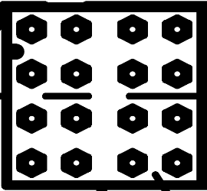
#1☐
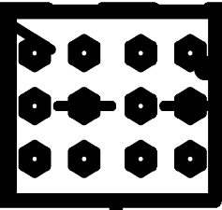
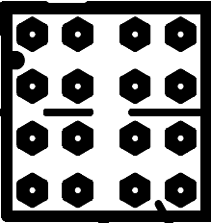
#3 ☐
#2 ☐

Comments/Punch List Items |  | Attachments
Verified by:  / / |  | Reviewed by Client:  / /

